Essential Skills
No matter what your choice is, there are a variety of “essential skills” you need in order to be successful which allow you to get a job and keep it. A skill is defined as something you can do with relative ease. In other words, just think about something you like to do, and that you are good at. For example, you may be a great snowboarder, or maybe you are a great artist. Perhaps you are efficient at downloading music or exceptional at playing a guitar. If you have a strength in a particular area, that is your skill.

This course is designed to help you prepare for all those new and exciting paths that will be coming when you enter postsecondary life, whether it be entering the world of work, or continuing on with another education path. The course is also designed to show you all the skills and qualities you bring on your journey to postsecondary life. No matter what your choice is, there are a variety of “essential skills” you need in order to be successful which allow you to get a job and keep it.

If something is essential, it means it is very important, so an essential skill is a very important skill needed in the workplace.

According to Human Resource and Skills Development Canada (HRSDC) there are nine essential skills:

- Reading Text
- Document Use
- Writing
- Numeracy
- Oral Communication
- Working with others
- Computer Use
- Continuous Learning
- Thinking Skills
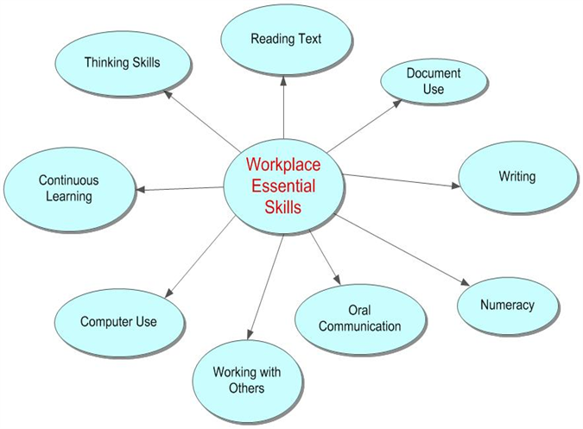Here are the nine essential workplace skills

Understanding the Nine Essential Workplace Skills
The Essential Skills are referred to as “enabling skills” that help people perform the tasks required by their jobs. Sometimes they may also be referred to as “transferable skills” because they are applicable across different occupations and sectors. The skills can be transferred from home to school, school to work, or occupation to occupation. These skills are also valuable around the community through daily tasks or volunteering. Regardless of how they are referred, it is important that you understand the meaning or description of each skill.

Essential Skills - Levels of Complexity
Different occupations may require a variety of levels of a particular essential skill. For example, the occupation of bricklayer requires a lower level of complexity regarding Writing, compared to a travel agent, whose job requires much more frequent and highly skilled writing.

Essential Skills - A Closer Look

Reading Text
Reading text refers to reading material that is in the form of sentences or paragraphs. It involves reading notes, letters, memos, manuals, specifications, regulations, books, reports, or journals. It also includes forms and labels if they contain at least one paragraph, print and non-print media, and paragraph-length text in charts, tables, and graphs.

Document Use
Document use refers to tasks that involve a variety of information displays in which words, numbers, icons, and other visual characteristics are given meaning by their spatial arrangement. For example, graphs, lists, tables, blueprints, schematics, drawings, signs, and labels are documents used in the world of work. Documents refer to both print and non-print media, such as a computer screen or microfiche documents, equipment gauges, clocks, and flags.
Print and non-print media often appear simultaneously as part of the same task. For example, completing a form, checking off items on a list of tasks, plotting information on a graph, and entering information on an activity schedule can be different steps in one task. Document use involves three dimensions of complexity which include complexity of the document, complexity of finding and entering information, and complexity of information use.

Writing
Writing includes writing texts and filling in forms, and non-paper based writing such as typing on a computer. Writing has three areas of complexity or difficulty: the length and purpose of the writing, its style and structure, and the content of the writing.

Numeracy
Numeracy refers to a worker's use of numbers, and being required to think in quantitative terms which includes numerical calculations and estimating involving money, scheduling or budgeting, and accounting, measurement and calculations, as well as analyzing math data.

Oral Communication
Oral communication pertains primarily to the use of speech to give and exchange thoughts and information by workers in an occupational group. It is important to realize that being able to speak is vital to your job if important messages are to be relayed. For example, if an important safety message is not delivered, a person's health may be at risk. Also, it is important to realize that communicating with your boss is much different than communicating with a fellow co-worker.

Computer Use
Computer use indicates the variety and complexity of computer use on a specific job. Depending on the job, employees may be expected to use a variety of computer programs from a word processor to a computer that operates a machine.

Working with Others

The skill of working with others examines the extent to which employees work with others to carry out their tasks. Do they have to work cooperatively with others? Do they have to have the self-discipline to meet work targets while working alone? This includes work context, which is the ways in which workers interact with one another to carry out their tasks. You may have to work independently, with partners, or as team members, as well as participation in Supervisory or Leadership Activities.

Continuous learning
Continuous learning has to do with the ability of workers in an occupational group to participate in an ongoing process of acquiring skill and knowledge. This may involve enrolling in college programs, or simply taking advantage of training opportunities within the workplace, or taking classes on the employee's own time to learn new skills. It is very important to always increase your knowledge, even if your job is secure, as each time you learn a new skill, you prepare yourself with additional skills that will help you advance in the workplace and be ready for advancement.

Thinking Skills
Thinking Skills has six main components:
- Problem Solving – involves problems that require solutions.
- Decision Making – refers to making a choice among options.
- Critical Thinking – refers to the process of making judgments. It is the process of evaluating ideas or information, or using a rational, logical thought process
- Job Task Planning and Organizing – refers to the extent to which the workers plan and organize their own tasks.
- Significant Use of Memory – includes any significant or unusual use of memory for workers such as purposeful memorization of procedures, codes, parts numbers, or remembering information for brief periods.
- Finding Information – involves using any variety of sources including text, people, computerized databases, or information systems.

ACTIVITY
Go to Human Resources Development Canada. Once you get to the site, read the information about essential skills profiles. Once you have read about what the profiles are all about, click on search the profiles at the bottom of your screen, and then select occupation. Now select three or four occupations of your choice, and learn about the essential skills involved in that occupation. Ensure you take notes outlining exactly what essential skills are involved with each occupation of your choice. You'll need this information for your first assignment.

Assignment 1 Occupations and Essential Skills
You've just learned about the nine essential workplace skills. You had the opportunity to investigate a few occupations of your choice. For this first assignment, you are required to look back on the occupations you investigated. Select two occupations, and describe the essential skills required for each occupation. In your response, comment on the complexity levels from 1 (basic tasks) to 4 or 5 (advanced tasks) for each essential skill relating to your chosen occupation. You may organize your response using a word processor or using a table such as this organizer.

Assignment 2 – What Are Your Skills?
Based on what you have learned so far about the essential workplace skills, briefly explain what you believe are some essential skills you already possess at this point in your life. Explain how you think these essential skills are transferable from home to the workplace, or to school based on your experiences thus far.

